# Homework #6: User Management

|  |
| --- |
| * This is an individual assignment and worth 20 points. * The due date is **Tuesday, March 29, 2022 Midnight**. * The database for the assignment (**AdventureWorks2016CTP3**) is installed on the Proxmox server. You are to download this document after you login to the Proxmox server. * You should answer the questions in blue. * You will get deductions if the requested screenshots are not provided. * Please zoom in your output. I will penalize you if your screenshots are too small. |

# Task #4. Assigning User Mappings to Fixed Database Roles

## A. Assigning a user to a database role

## B. Verifying the results

5) Does it fail? Show the result in a screenshot. Describe your observation and explain why it fails.

It failed because TestUser-A does not have the authority to write, modify, or update the AdventureWorks2016 Database. It only has the public role. It cannot directly interact with the database.

10) Does it fail? Show the result in a screenshot. Describe your observation and explain why it fails.

It did fail because TestUser-B is assigned a role called db_denydatareader that does not allow the user to view database contents/information.

# Task #5. Creating a Custom Database Role

## A. Creating a custom database role

## B. Verifying results

4) Does it work? Show the result in a screenshot. Describe your observation and explain why it works.

The query is a success because TestUser-C was given permission to select and read data from the human resources department table with the newly created SelectOnly role.

5) Does it fail? Show the result in a screenshot. Describe your observation and explain why it fails.

It failed because TestUser-C can only read and select data from the human resources department table. The user cannot modify or create new entries due to the lack of permissions to do so.

# Task #6. Creating an Application Role

## A. Creating an Application Role

## B. Verifying Results

2) Does it fail? Show the result in a screenshot. Describe your observation and explain why it fails.

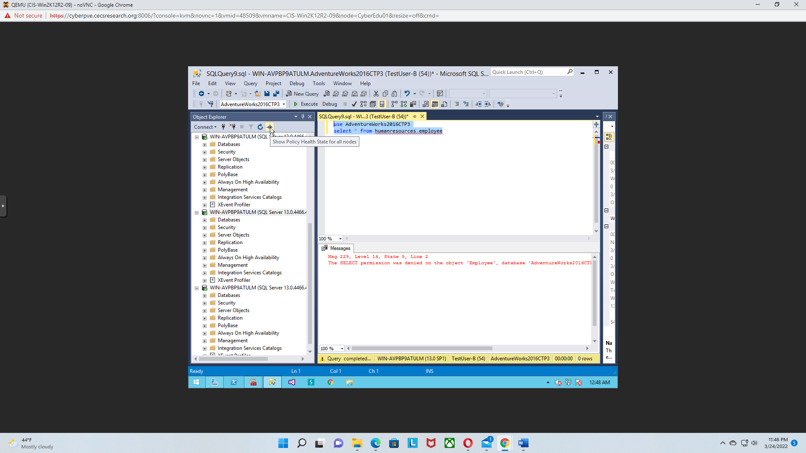

The query failed due to that TestUser-B does not have permission to select/read data from the human resources employee table.

4) Does it work? Show the result in a screenshot. You have to click on Results to view the results. Describe your observation and explain why it works.

The query does work and TestUser-B now is able to select/read the Employee table due to the user receiving the new role *EntAppRole,*which grants the user the ability to select data from the Employee table.

# Task #7. Assigning Permissions

9) Does it work? Show the result in a screenshot. Describe your observation and explain why it works.

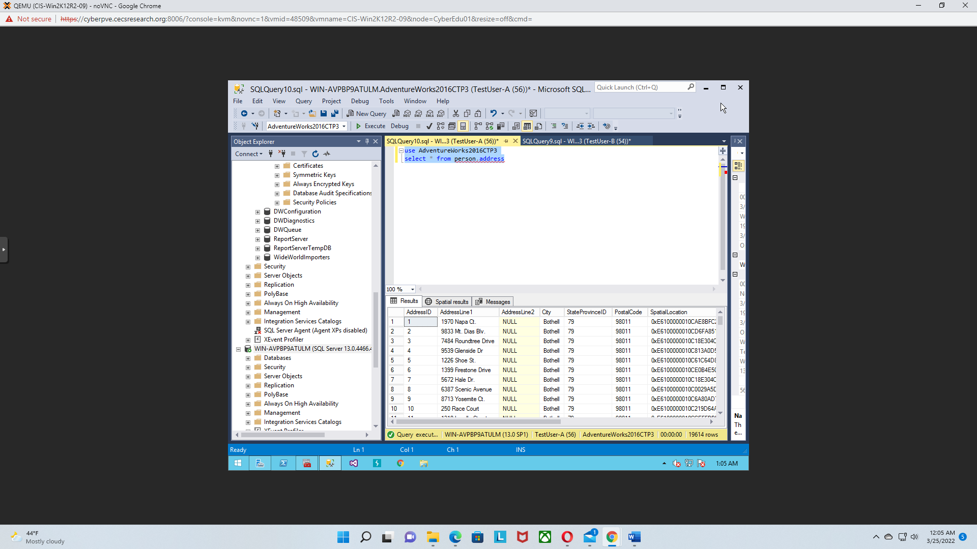

The query works due to that TestUser-A was given permission to select/read data from the person.address table.

13) Run the previous query. Show the result in a screenshot. Describe your observation and explain why it fails.

This query failed because the permission to select data from the person.address table was removed from TestUser-A.

15) Run the previous query. Show the result in a screenshot. Describe your observation and explain why it works.

This query works because TestUser-A received the db_datareader role and is able to read the data from the person.address table.

19) Run the previous query. Show the result in a screenshot. Describe your observation and explain why it fails.

The query failed because TestUser-A has been denied permission to select data from the person.addrss table.